External Curve Tangency
# Source: AI Source: Provided by: [Data Path: Persons Table -> ID Column: 1, Name_En Column: Motasem Essam] -> From: [ChatGPT] on [7/25/2026]
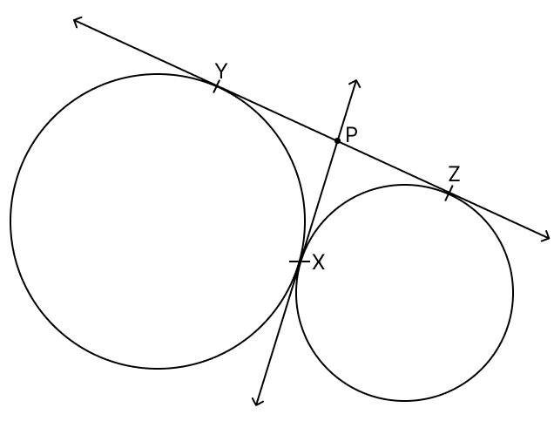
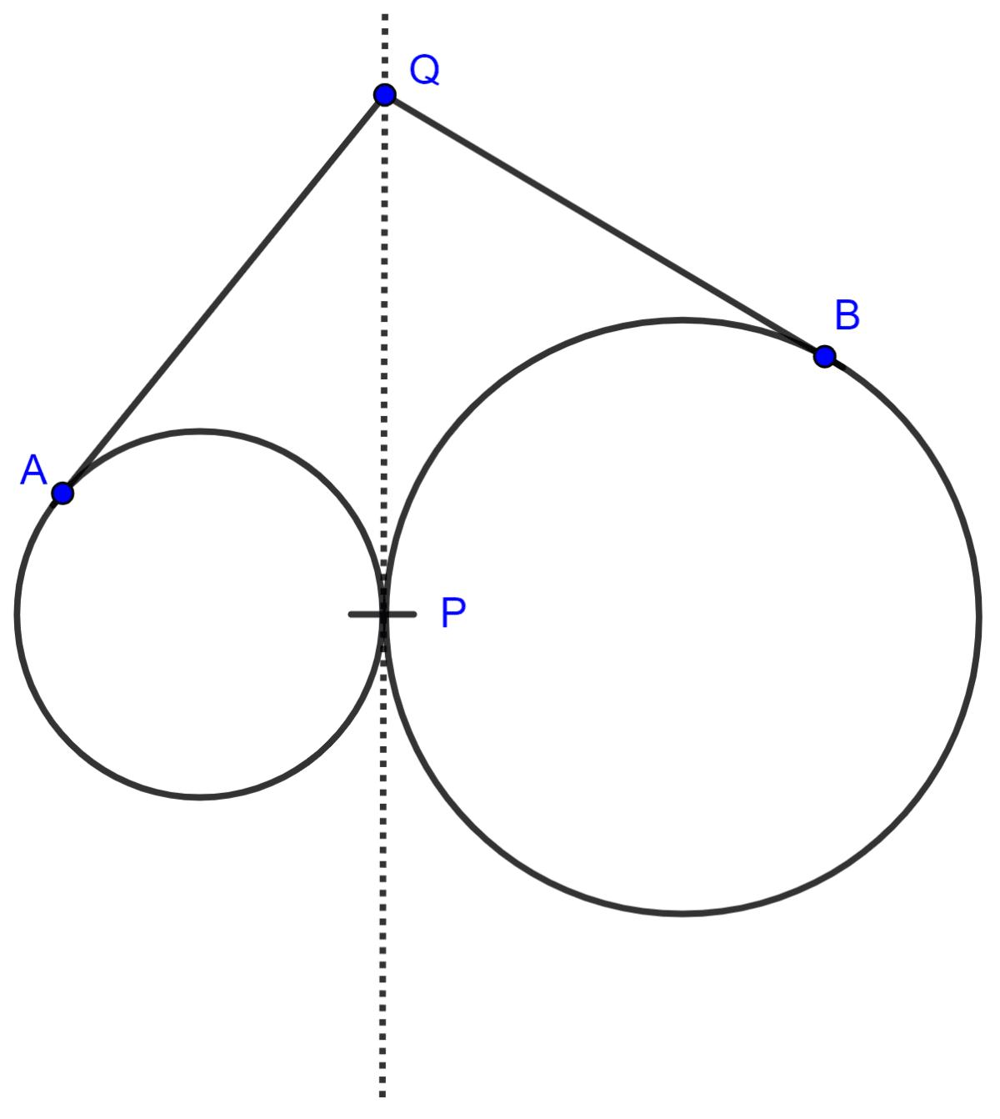
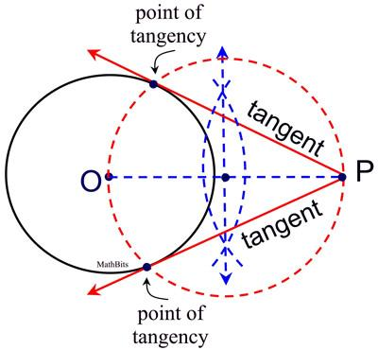

Definition
# Source: AI Source: Provided by: [Data Path: Persons Table -> ID Column: 1, Name_En Column: Motasem Essam] -> From: [ChatGPT] on [7/25/2026]
External Curve Tangency is a type of Curve–Curve Tangency in which two curves touch at exactly one common point while remaining on separate sides of the local contact.
The common point is called the point of tangency.
At the tangency point, the two curves have the same tangent line.
Unlike circle–circle external tangency, which has a simple radius-distance formula, general curve–curve tangency is defined primarily by the curves having first-order contact at the tangency point.

Fundamental Concept
# Source: AI Source: Provided by: [Data Path: Persons Table -> ID Column: 1, Name_En Column: Motasem Essam] -> From: [ChatGPT] on [7/25/2026]
Let two curves be $C_{1}$and $C_{2}$, and let $T$be their point of tangency.
For external tangency:
$$\boxed{T∈C_{1}∩C_{2}}$$
and the two curves have the same tangent direction at $T$.
Therefore:
$$\boxed{{\text{Tangent}}_{C_{1}}\left(T\right)={\text{Tangent}}_{C_{2}}\left(T\right)}$$
The curves touch at $T$without crossing through each other locally.

Main Parts
# Source: AI Source: Provided by: [Data Path: Persons Table -> ID Column: 1, Name_En Column: Motasem Essam] -> From: [ChatGPT] on [7/25/2026]
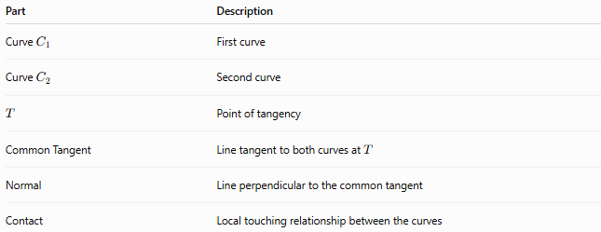
Part | Description
Curve $C_{1}$ | First curve
Curve $C_{2}$ | Second curve
$$T$$ | Point of tangency
Common Tangent | Line tangent to both curves at $T$
Normal | Line perpendicular to the common tangent
Contact | Local touching relationship between the curves

Basic Diagram
# Source: AI Source: Provided by: [Data Path: Persons Table -> ID Column: 1, Name_En Column: Motasem Essam] -> From: [ChatGPT] on [7/25/2026]
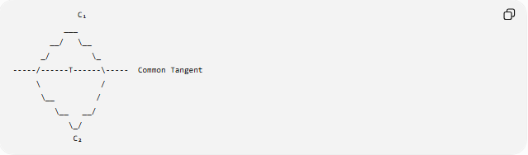
C₁
___
__/ \__
_/ \_
-----/------T------\----- Common Tangent
\ /
\__ /
\__ __/
\_/
C₂
At $T$, both curves have the same tangent line.
The essential condition is:
$$\boxed{\text{same tangent direction at }T}$$

Defining Properties

1-One Common Tangency Point
# Source: AI Source: Provided by: [Data Path: Persons Table -> ID Column: 1, Name_En Column: Motasem Essam] -> From: [ChatGPT] on [7/25/2026]
The curves touch at a common point $T$:
$$\boxed{T∈C_{1}∩C_{2}}$$
For the basic case, this is the only intersection near the contact.

2-Common Tangent Line
# Source: AI Source: Provided by: [Data Path: Persons Table -> ID Column: 1, Name_En Column: Motasem Essam] -> From: [ChatGPT] on [7/25/2026]
Both curves have the same tangent line at $T$:
$$\boxed{L_{1}=L_{2}}$$
where $L_{1}$and $L_{2}$are their tangent lines.

3-No Local Crossing
# Source: AI Source: Provided by: [Data Path: Persons Table -> ID Column: 1, Name_En Column: Motasem Essam] -> From: [ChatGPT] on [7/25/2026]
For external tangency, the curves remain locally separated on the appropriate sides of the common tangent.
They touch at $T$rather than crossing through one another.

Tangent-Slope Condition
# Source: AI Source: Provided by: [Data Path: Persons Table -> ID Column: 1, Name_En Column: Motasem Essam] -> From: [ChatGPT] on [7/25/2026]
If both curves can be represented locally as functions:
$$y=f\left(x\right)$$
and:
$$y=g\left(x\right)$$
and they are tangent at:
$$T=\left(x_{0} , y_{0}\right)$$
then:
$$f\left(x_{0}\right)=g\left(x_{0}\right)$$
and:
$$\boxed{f^{'}\left(x_{0}\right)=g^{'}\left(x_{0}\right)}$$
The first equation means that the curves pass through the same point.
The second means that they have the same tangent slope there.

Parametric Curves
# Source: AI Source: Provided by: [Data Path: Persons Table -> ID Column: 1, Name_En Column: Motasem Essam] -> From: [ChatGPT] on [7/25/2026]
For parametric curves:
$$r_{1}\left(t\right)$$
and:
$$r_{2}\left(u\right)$$
external tangency at $T$requires:
$$\boxed{r_{1}\left(t_{0}\right)=r_{2}\left(u_{0}\right)=T}$$
and their tangent vectors must be parallel:
$$\boxed{r_{1}^{'}\left(t_{0}\right)∥r_{2}^{'}\left(u_{0}\right)}$$
Thus, the two curves have the same tangent direction at their contact point.

Implicit Curves
# Source: AI Source: Provided by: [Data Path: Persons Table -> ID Column: 1, Name_En Column: Motasem Essam] -> From: [ChatGPT] on [7/25/2026]
For curves represented by:
$$F\left(x , y\right)=0$$
and:
$$G\left(x , y\right)=0$$
a common point $T=\left(x_{0} , y_{0}\right)$satisfies:
$$F\left(x_{0} , y_{0}\right)=0$$
and:
$$G\left(x_{0} , y_{0}\right)=0$$
For tangency, their gradients at $T$are parallel:
$$\boxed{∇F\left(x_{0} , y_{0}\right)∥∇G\left(x_{0} , y_{0}\right)}$$
Because the gradient is normal to the curve, parallel gradients imply a common tangent direction.

Circle–Circle External Tangency
# Source: AI Source: Provided by: [Data Path: Persons Table -> ID Column: 1, Name_En Column: Motasem Essam] -> From: [ChatGPT] on [7/25/2026]
Circle–circle tangency is an important special case.
Suppose two circles have radii $R_{1}$and $R_{2}$, with center distance $d$.
For external tangency:
$$\boxed{d=R_{1}+R_{2}}$$
Their tangency point $T$lies between the two centers:
$$\boxed{O_{1}-T-O_{2}}$$
and:
$$\boxed{O_{1}T=R_{1}} \\ \boxed{TO_{2}=R_{2}}$$
Therefore:
$$O_{1}O_{2}=R_{1}+R_{2}$$

External vs Internal Curve Tangency
# Source: AI Source: Provided by: [Data Path: Persons Table -> ID Column: 1, Name_En Column: Motasem Essam] -> From: [ChatGPT] on [7/25/2026]
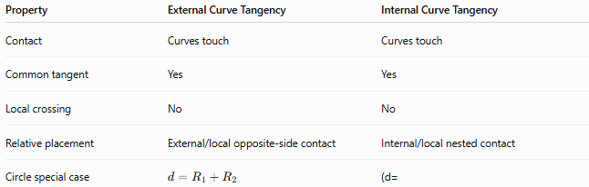
Property | External Curve Tangency | Internal Curve Tangency
Contact | Curves touch | Curves touch
Common tangent | Yes | Yes
Local crossing | No | No
Relative placement | External/local opposite-side contact | Internal/local nested contact
Circle special case | $$d=R_{1}+R_{2}$$ | (d=
For general curves, unlike circles, there is not one universal distance formula equivalent to the circle formulas.

Tangency vs Intersection
# Source: AI Source: Provided by: [Data Path: Persons Table -> ID Column: 1, Name_En Column: Motasem Essam] -> From: [ChatGPT] on [7/25/2026]
Two curves can meet in several different ways.
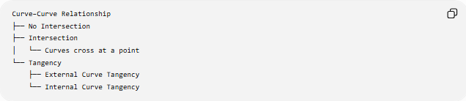
Curve–Curve Relationship
├── No Intersection
├── Intersection
│ └── Curves cross at a point
└── Tangency
├── External Curve Tangency
└── Internal Curve Tangency
At ordinary intersection:
$$\boxed{\text{different tangent directions}}$$
At tangency:
$$\boxed{\text{same tangent direction}}$$

Example
# Source: AI Source: Provided by: [Data Path: Persons Table -> ID Column: 1, Name_En Column: Motasem Essam] -> From: [ChatGPT] on [7/25/2026]
Consider:
$$y=x^{2}$$
and:
$$y=x^{2}+1$$
These curves have the same shape and tangent directions everywhere, but they do not touch because:
$$x^{2}≠x^{2}+1$$
at every $x$.
Therefore, having parallel or identical tangent directions alone is not sufficient for tangency.
The curves must first share the same point.
For tangency at $x=x_{0}$, both conditions are required:
$$\boxed{f\left(x_{0}\right)=g\left(x_{0}\right)}$$
and:
$$\boxed{f^{'}\left(x_{0}\right)=g^{'}\left(x_{0}\right)}$$

Example of Curve Tangency
# Source: AI Source: Provided by: [Data Path: Persons Table -> ID Column: 1, Name_En Column: Motasem Essam] -> From: [ChatGPT] on [7/25/2026]
Consider:
$$y=x^{2}$$
and:
$$y=2x^{2}$$
At $x=0$:
$$0^{2}=2{\left(0\right)}^{2}=0$$
so both curves pass through:
$$T=\left(0 , 0\right)$$
Their derivatives are:
$$f^{'}\left(x\right)=2x$$
and:
$$g^{'}\left(x\right)=4x$$
At $x=0$:
$$f^{'}\left(0\right)=g^{'}\left(0\right)=0$$
Therefore, the curves have the same tangent line at $T$:
$$\boxed{y=0}$$
They are tangent at the origin.

Higher-Order Contact
# Source: AI Source: Provided by: [Data Path: Persons Table -> ID Column: 1, Name_En Column: Motasem Essam] -> From: [ChatGPT] on [7/25/2026]
Two curves can have the same tangent but still have different types of contact.
For example:
$$y=x^{2}$$
and:
$$y=-x^{2}$$
both have tangent line:
$$y=0$$
at:
$$\left(0 , 0\right)$$
but they lie on opposite sides of the tangent line.
This illustrates why external/internal classification for general curves depends on local geometry, not simply on a radius-distance formula.

Important Distinction
# Source: AI Source: Provided by: [Data Path: Persons Table -> ID Column: 1, Name_En Column: Motasem Essam] -> From: [ChatGPT] on [7/25/2026]
External curve tangency should not be confused with:
External Circle Tangency
A specific circle–circle configuration:
$$\boxed{d=R_{1}+R_{2}}$$
External Curve Tangency
A more general concept involving arbitrary curves, defined by:
- a common point,
- a common tangent direction,
- and local external contact.
Thus:
$$\boxed{\text{Circle–Circle External Tangency is a special case of Curve–Curve Tangency}}$$

Applications
# Source: AI Source: Provided by: [Data Path: Persons Table -> ID Column: 1, Name_En Column: Motasem Essam] -> From: [ChatGPT] on [7/25/2026]
External curve tangency appears in:
- Computer graphics
- CAD and geometric modeling
- Industrial design
- Robotics
- Motion planning
- Road and track design
- Bézier curve construction
- Computer-aided manufacturing
- Mechanical engineering
- Optimization
- Geometric collision detection

Key Points
# Source: AI Source: Provided by: [Data Path: Persons Table -> ID Column: 1, Name_En Column: Motasem Essam] -> From: [ChatGPT] on [7/25/2026]
- External Curve Tangency occurs when two curves touch externally at a common point.
- The common point is the point of tangency.
- The two curves have the same tangent line at that point.
- For $y=f\left(x\right)$and $y=g\left(x\right)$:
$$\boxed{f\left(x_{0}\right)=g\left(x_{0}\right)}$$
and:
$$\boxed{f^{'}\left(x_{0}\right)=g^{'}\left(x_{0}\right)}$$
- For parametric curves, their tangent vectors are parallel at the contact point.
- For implicit curves, their gradients are parallel at the contact point.
- Circle–circle external tangency is a special case:
$$\boxed{d=R_{1}+R_{2}}$$
- General curves do not have a universal radius-distance formula.
- Tangency means the curves share a tangent direction; ordinary crossing involves different tangent directions.

Conclusion
# Source: AI Source: Provided by: [Data Path: Persons Table -> ID Column: 1, Name_En Column: Motasem Essam] -> From: [ChatGPT] on [7/25/2026]
External Curve Tangency is a general curve–curve relationship in which two curves meet at a common point and have the same tangent line there, while remaining locally on separate sides rather than crossing through each other.
For explicit curves:
$$\boxed{f\left(x_{0}\right)=g\left(x_{0}\right), f^{'}\left(x_{0}\right)=g^{'}\left(x_{0}\right)}$$
For circles, this general concept becomes the familiar external circle tangency condition:
$$\boxed{d=R_{1}+R_{2}}$$
Thus, external curve tangency provides the general geometric framework, while circle–circle external tangency is one of its most important special cases.

